

Sultan Qaboos University

College of Science

Department of computer science

COMP3700: Introduction to Web Computing

(Fall23)



CAMPUS COMPASS

-Part 4-

Bushra hamed alhashmi 129209

Amna Ali Albalushi 136368

Rund Abdulaziz Alrasbi 136686

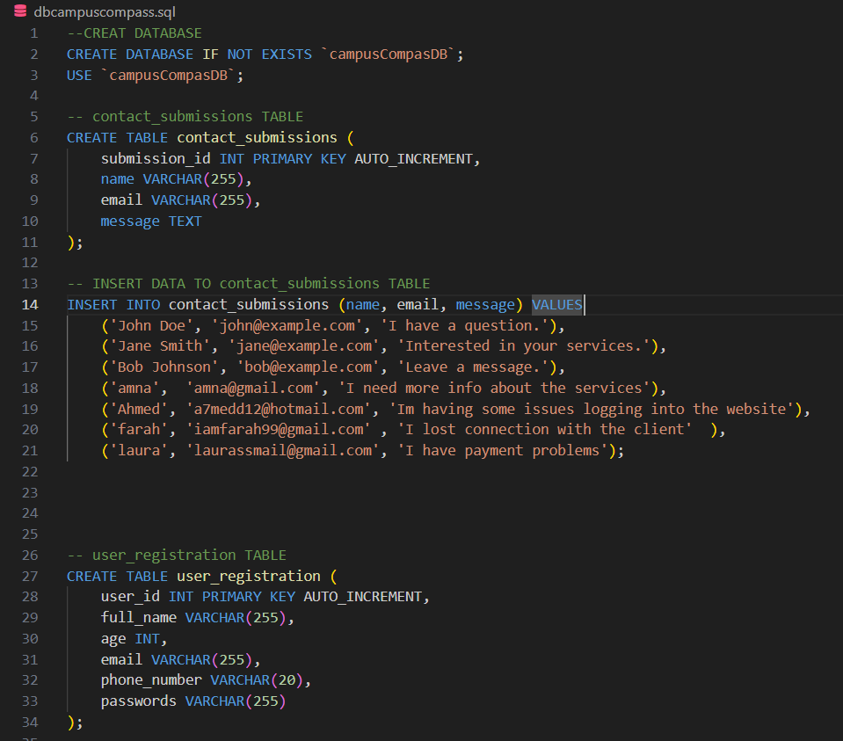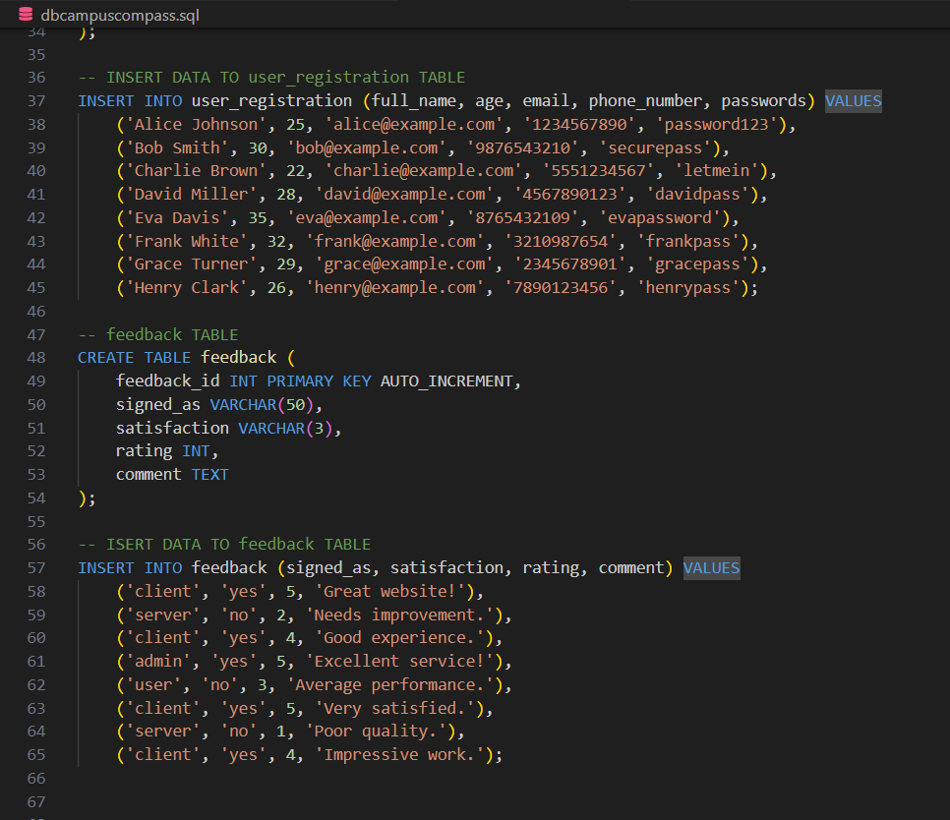Q1: SQl Code

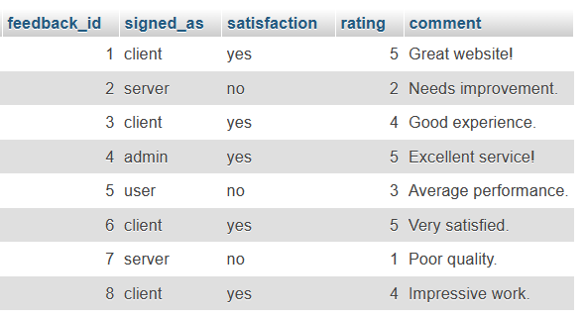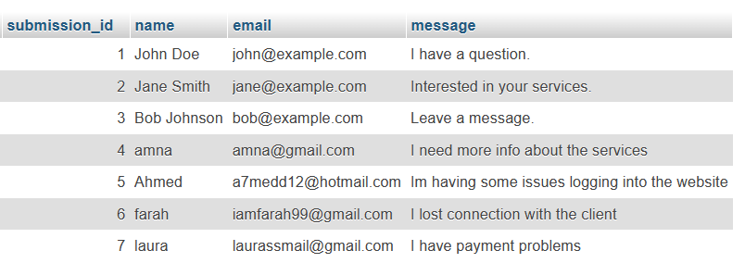contact_submissions table :

Feedback table:

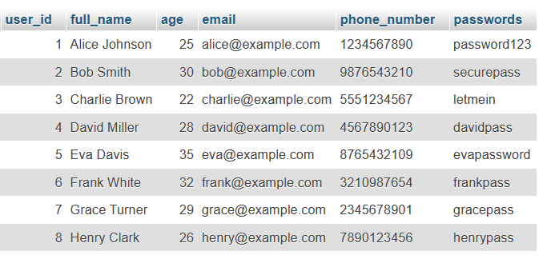user_registraion table:

Q2:

We constructed the corresponding PHP page that will process all received formation for Questionnaire form and send the entered information to the corresponding PHP pages instead of JavaScript functions.

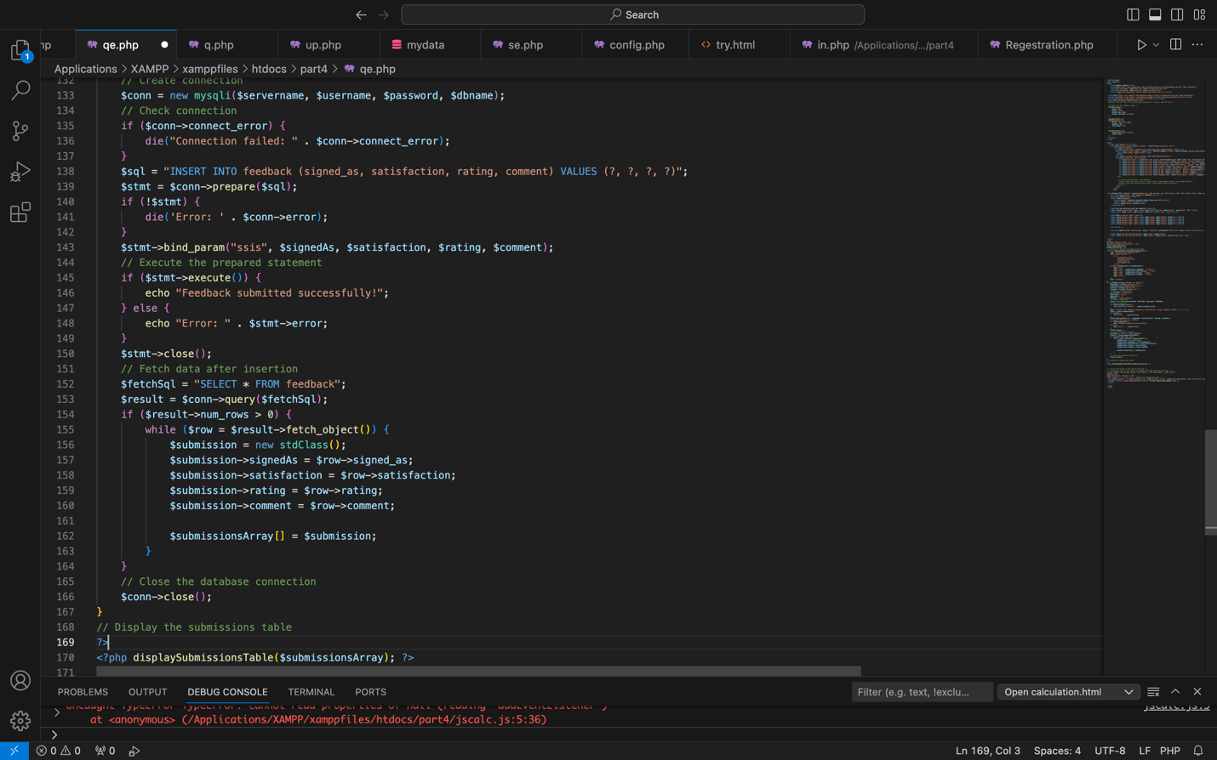

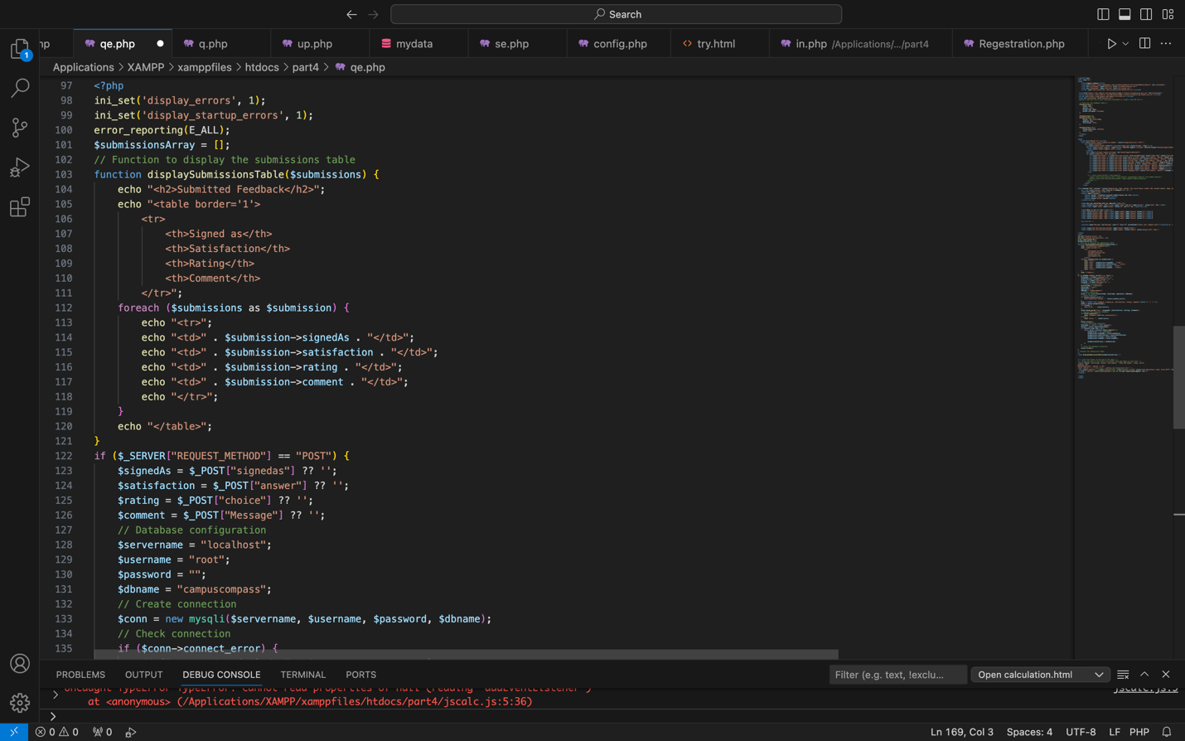

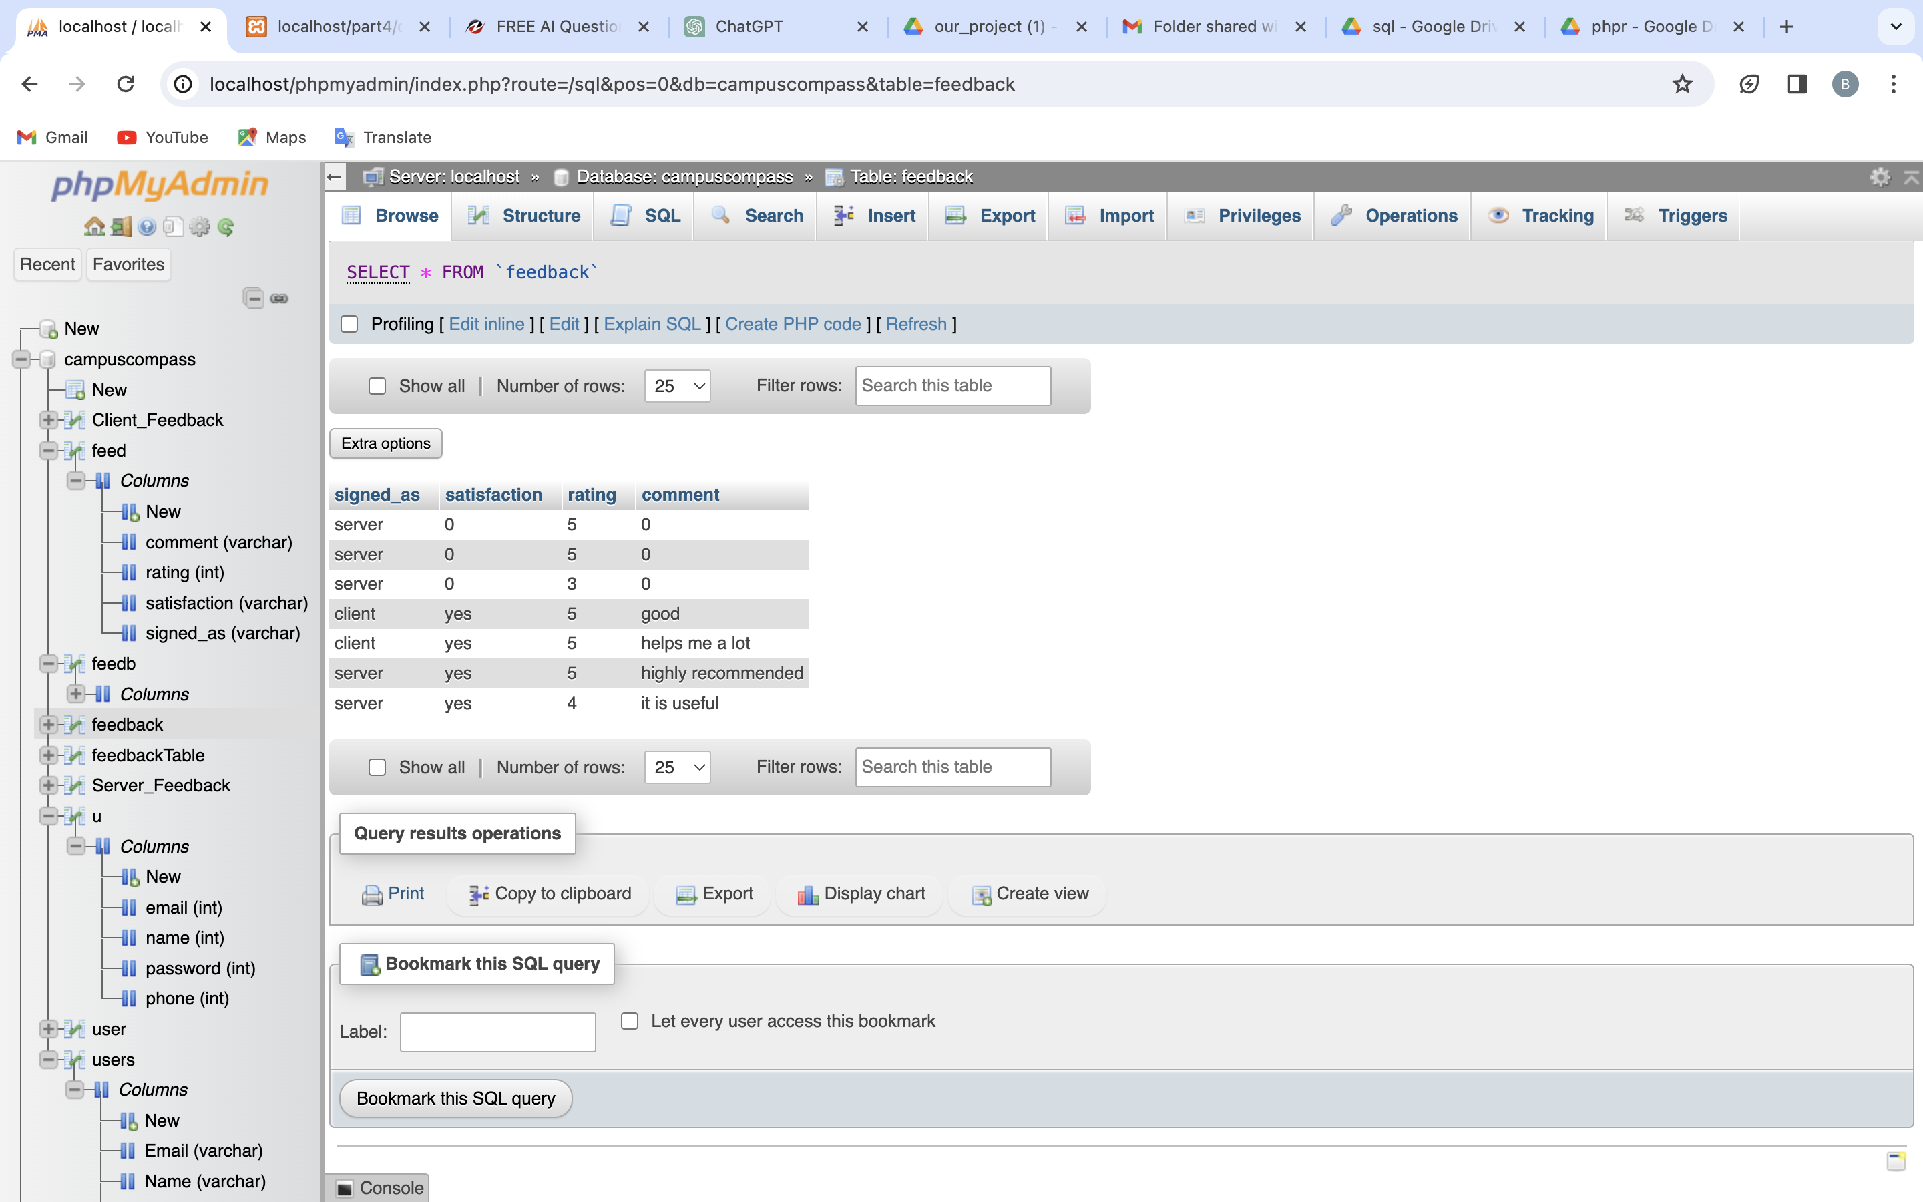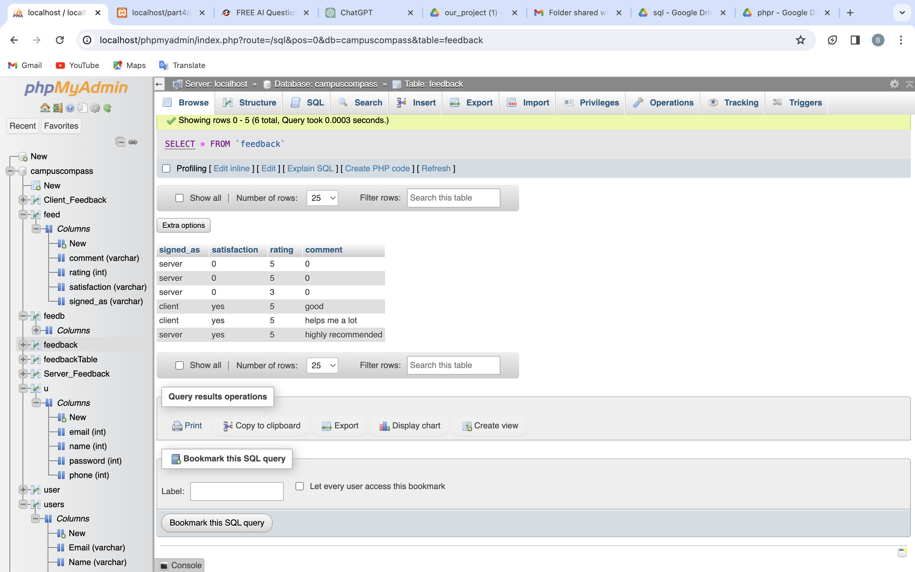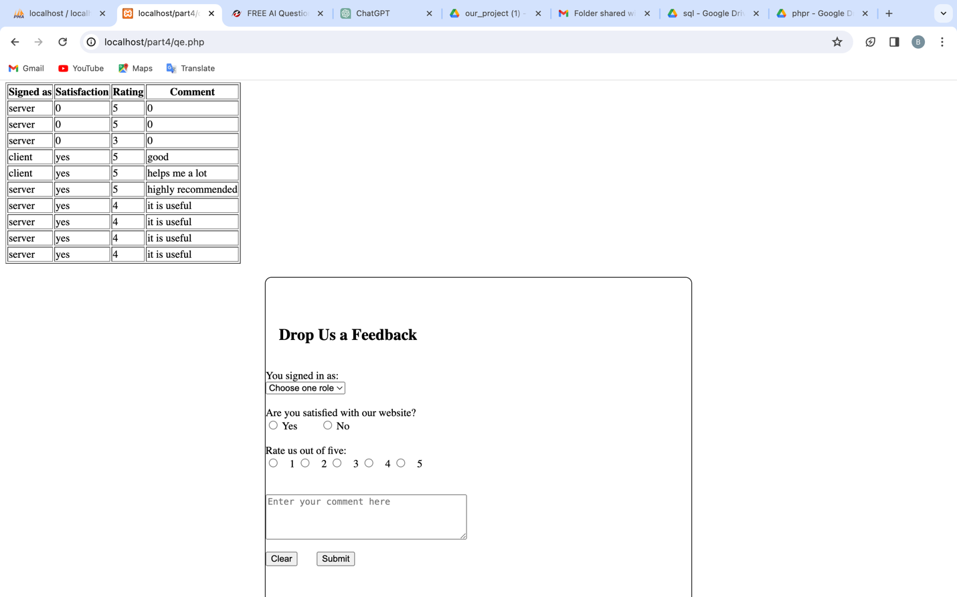

Q3:

Search query and displaying the result in HTML elements

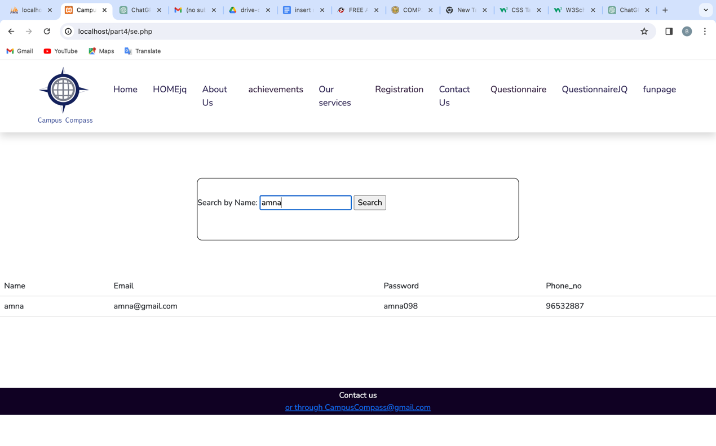

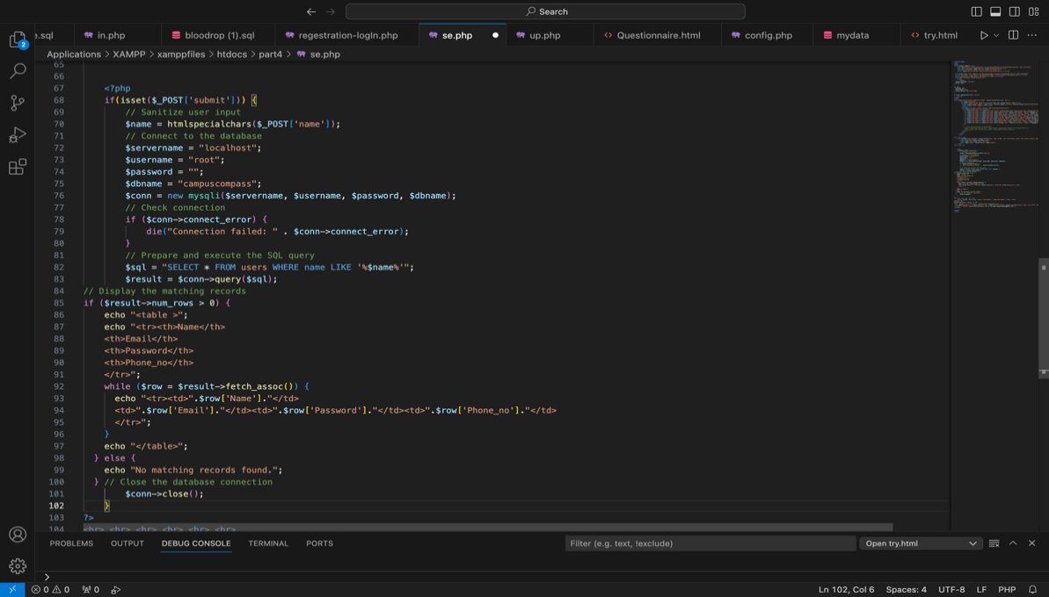

Here user can search by name from database and then table contain all information about that user

Two SQU (Insert and Update) queries, statement to update DB and appropriate HTML elements

Insert :

In log in page user can enter his information and it stored in database

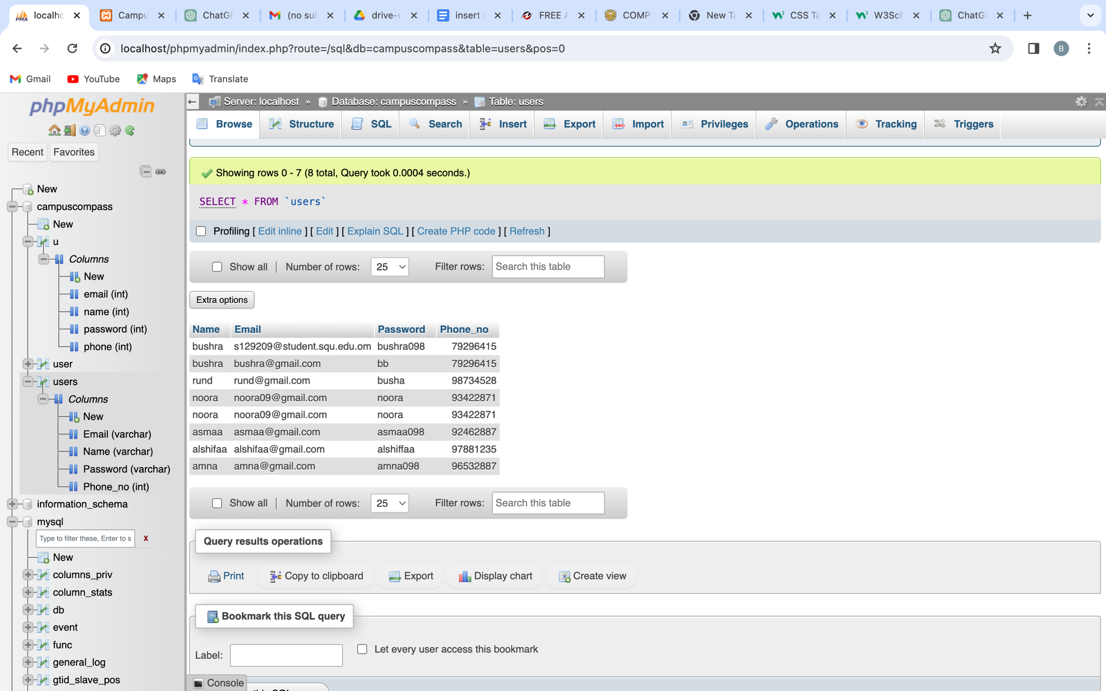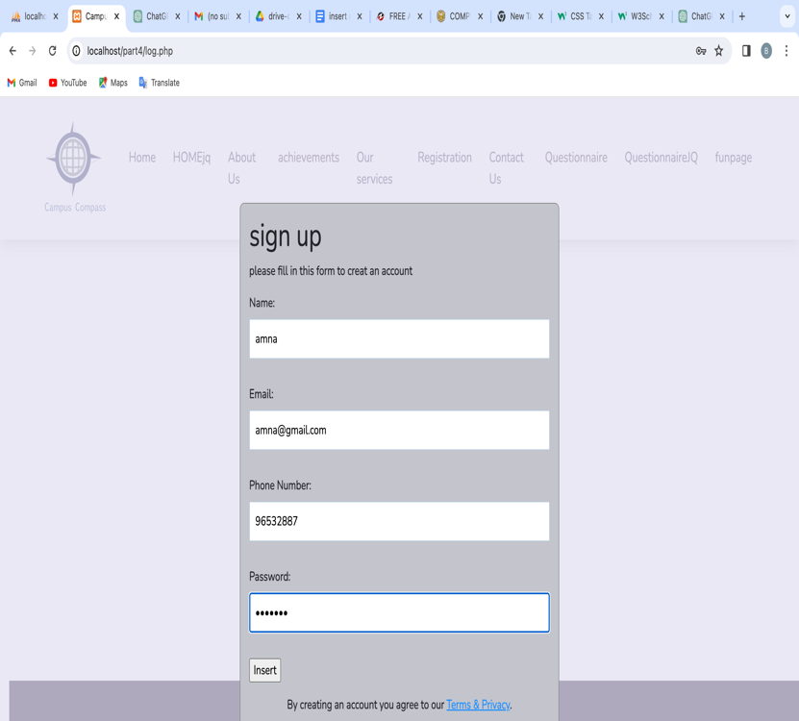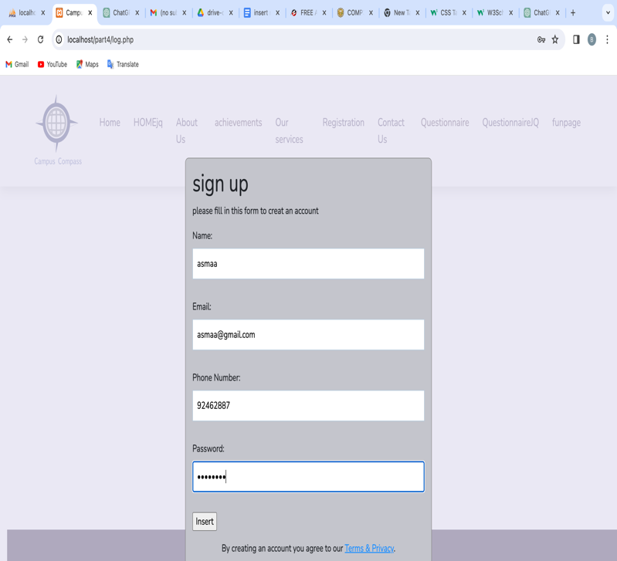

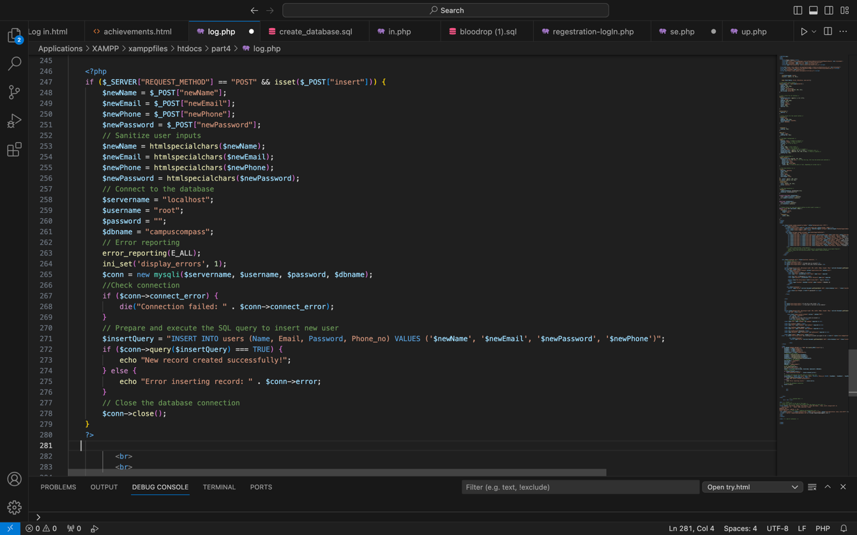

Update :

User can update his information by searching his name and then complete the form with new data to update the database

Before update:



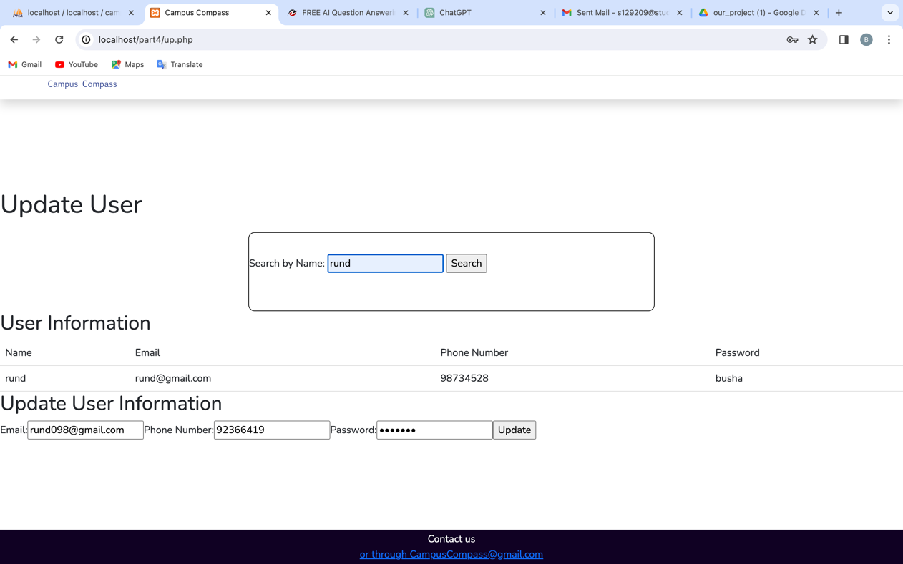

After update :

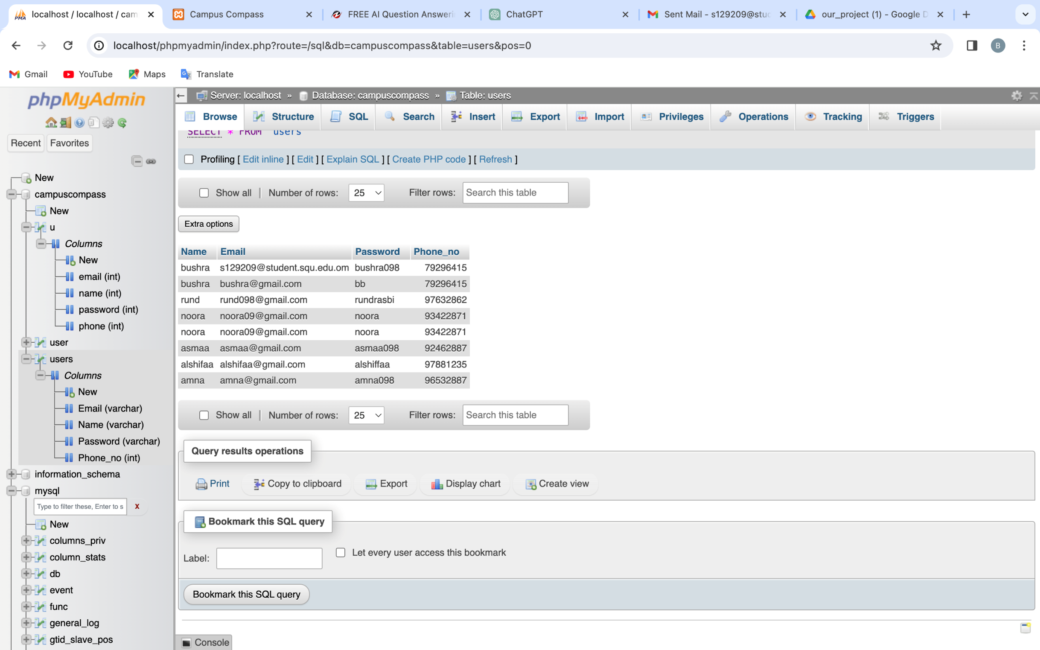

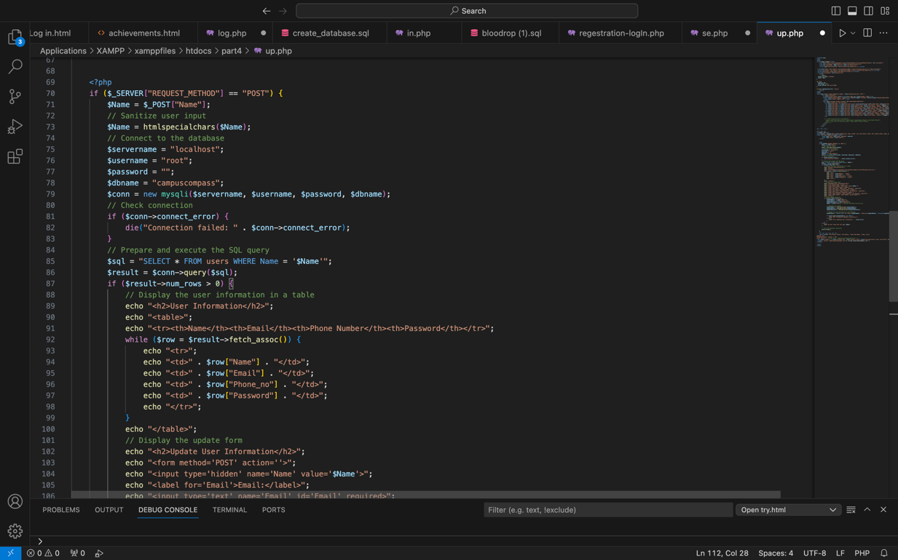

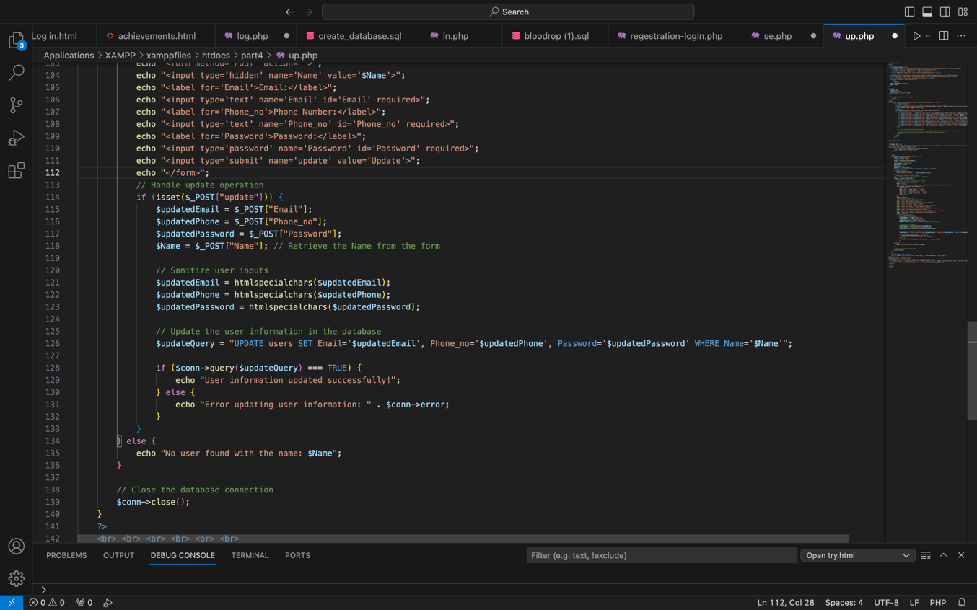

|  |  |  |  |
| --- | --- | --- | --- |
| Component | Contributor(s) | Percentage | Comments |
| Q1 | Rund alrasbi | 100% |  |
| Q2 | Amna albulushi | 100% |  |
| Q3 | Bushra alhashmi | 100% |  |
| Report | Bushra alhashmi  Rund alrasbi  Amna albulushi |  | Each one added her question part |